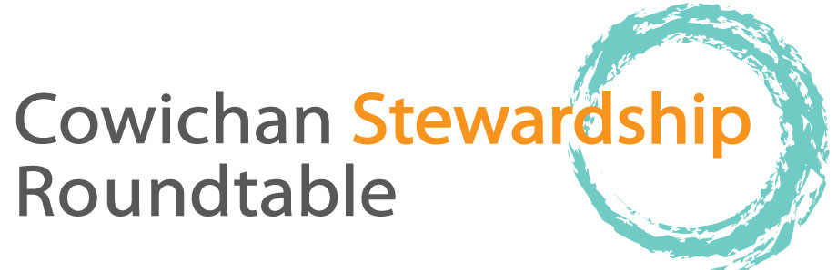

December 18, 2014 AGENDA

Meeting venue - Freshwater Fisheries Society 1080, Wharncliffe Rd, 9:00 – 12:00, followed by Christmas Social 12:00-1:00, please allow enough room in parking lot for Trout Hatchery vehicles and emergency vehicles

9:00 AM Welcome, apologies, agenda changes,
In attendance List to be circulated
Approval of Minutes (as circulated from Meg Loop)
Housekeeping items (Genevieve)
Co-chair situation
9:10 Around the Table updates as to projects, activities since last meeting
9:45 - 10:25 James Craig and Kevin Pellett on River distribution of chinook fry / smolts, habitat utilization and mortalities for fry.

10:25 AM Break (10 min)
10:35 – 10:50 Rodger Hunter on Watershed management Board Activity, planning, Cowichan Estuary Management Committee.
10:50-11:20 Cheri Ayers on Cowichan Chinook Rebuilding Plan
11:20-11.50 David Preikshot on Somenos Marsh monitoring
11:50 New Business / Set agenda for next meeting on January 15, 2015.
12:00 to 1:00 potluck social in lobby. Please bring a finger food, savory or sweet, to share and your coffee mug. Plates and punch mugs provided. Please help make this a green event. If you do not have time to bring food please come anyways, Genevieve will bring extras. Looking forward to seeing you there, open to all.

