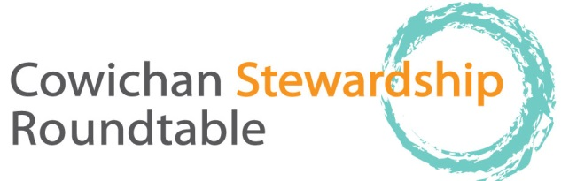

thursday, Nov. 19, 9-12 AM. Everyone welcome.
Old Freshwater Ecocentre, Freshwater Fisheries Society, 1080 Wharncliffe Rd, 9:00–12:00
Please allow enough room in parking lot for Trout Hatchery vehicles and emergency vehicles, no parking in yellow painted areas, bring your coffee cup!

9:00 welcome and acknowledgement that our meeting is on Cowichan Tribes territory, regrets, agenda changes, Attendance list to be circulated
Approval of Minutes (thank you Meg Loop!)
9:10 Round the Table: BRIEF updates as to projects, activities since last meeting
10:30 Break (10 min)

10:40: Report from Brian Houle on Catalyst’s section 8 permit application.

10.55 Cowichan Climate Change Collaborative Project: Parker, Michelle Staples
11:30 Knotweed project: Cherie Ayers, Dave Lindsay, Genevieve Singleton, David Polster
11:45 Would we like to do a social gathering after our next meeting, Dec. 17? In the past we have done finger food potluck, 12-1. Thoughts. At our December meeting Christine Brophy and others from Cowichan Lake River Stewardship Society will be presenting update on their work around Lake Cowichan. Cowichan Land Trust will be doing a presentation in the new year on their work. We continue to try and set up a talk on seals in Cowichan Bay.
12:00 sharp: conclusion of meeting
Future meetings: December, Christine Brophy and CLRSS members talk on Lake Cowichan projects, Our meetings are always the third Thursday of the month, with the possible exception of August. Until further notice meetings are at the old Freshwater Ecocentre.

