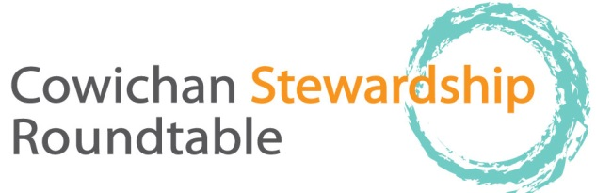

thursday, October 15, 9-12 AM. Everyone welcome.
Old Freshwater Ecocentre, Freshwater Fisheries Society, 1080 Wharncliffe Rd, 9:00–12:00
Please allow enough room in parking lot for Trout Hatchery vehicles and emergency vehicles, no parking in yellow painted areas, bring your coffee cup!

9:00 welcome and acknowledgement that our meeting is on Cowichan Tribes territory, regrets, agenda changes, Attendance list to be circulated
Approval of Minutes (thank you Meg Loop!)
9:10 Round the Table: BRIEF updates as to projects, activities since last meeting
10:30 Break (10 min)

10:40: Nature Cowichan information – likely John Scull

10:50 Discussion on Dinsdale Farm in Cowichan Estuary. It is hoped that reps from FLMRO, Ducks Unlimited, Nature Trust and CWS will be able to attend. Paul Rickard, Ray Demarchi and Carol Hartwig presenting information.
11:50 updates re future topics, does CSRT want to invite Austen Thomas to talk about his completed research on seals? Christine Brophey and CLRSS will be presenting re lake projects soon, Tim Clermont will present in the spring re Somenos Management Plan, not November.
12:00 sharp: conclusion of meeting
Future meetings: Tim Clermont from NCC speaking on Somenos Wildlife Management Area in the spring; Christine Brophy and CLRSS talking on update re Lake Projects soon, Andrew Martel of Canada Museum (Quebec) on fresh water mussels research sometime in New Year.
Our meetings are always the third Thursday of the month, with the possible exception of August. Until further notice meetings are at the old Freshwater Ecocentre.

